**ROHITH RAJAGOPALAN**

**1001518031**

[**2208-CSE-5382-001**](https://uta.instructure.com/courses/62497)

**Assignment 4: Return-to-libc Attack**

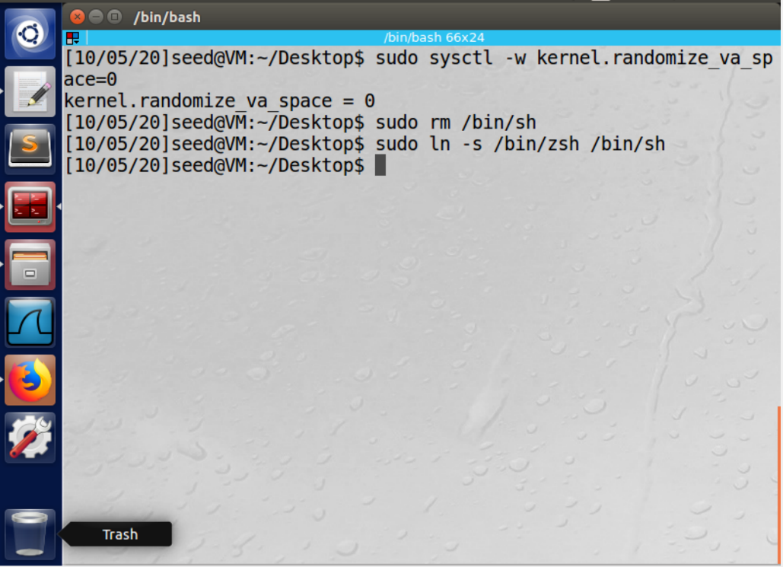

**Task 1: Finding out the addresses of libc functions**

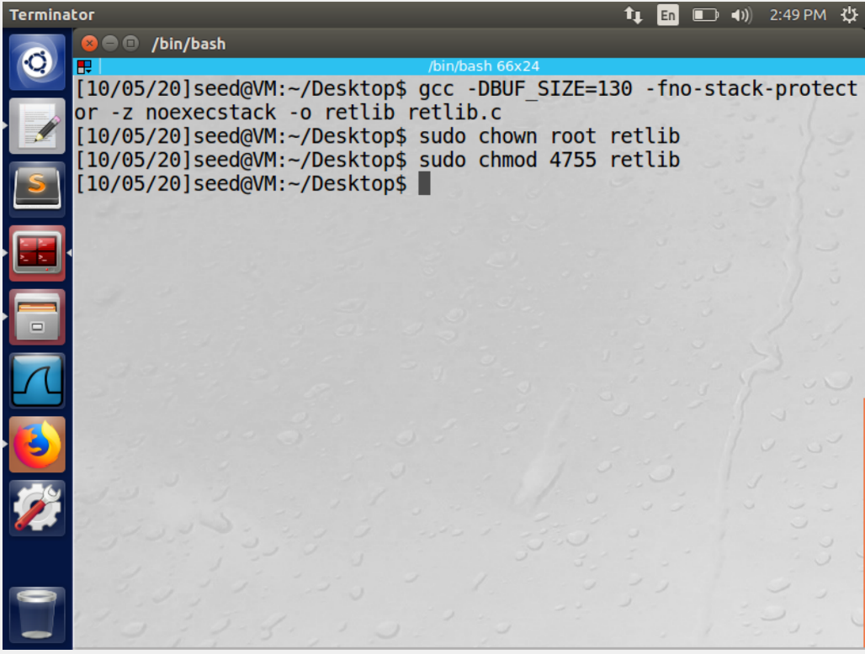

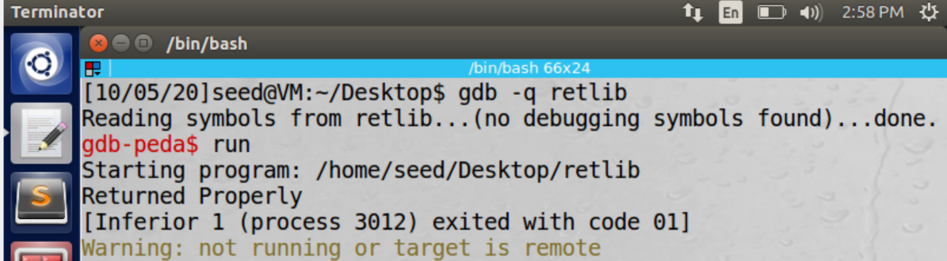

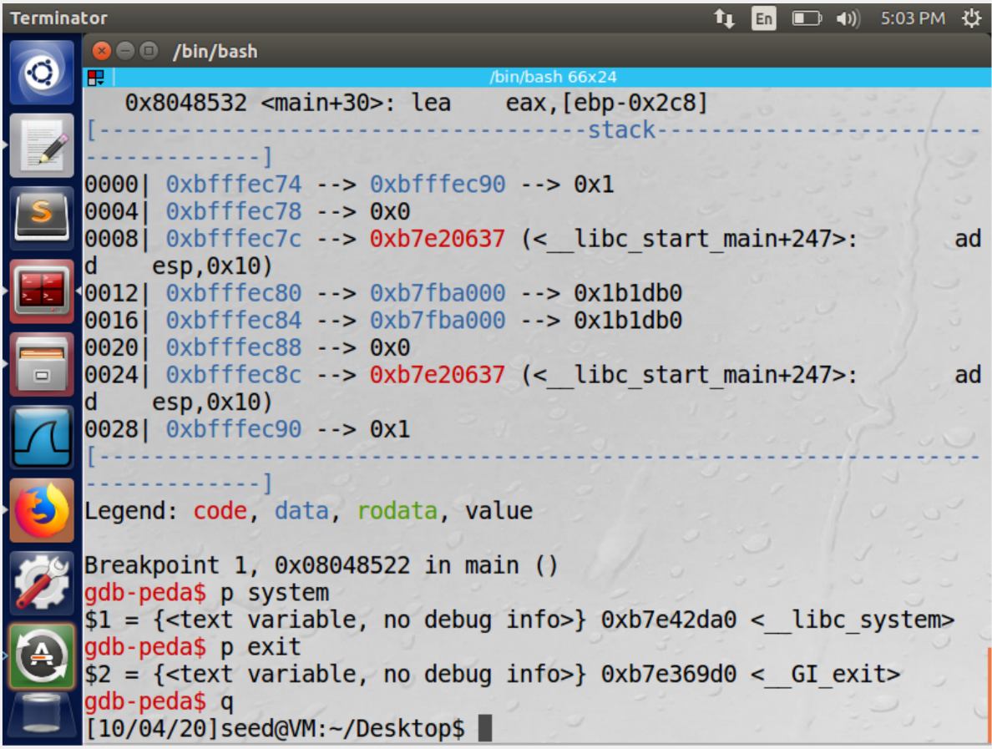

In this task we are required to find the addresses of the libc functions p system and p exit. We run the retlib program as directed in the manual in debugging mode. We then set a breakpoint using the b main command. We print the addresses of the libc functions using the p system and p exit commands.

**Task 2: Putting the shell string in the memory**

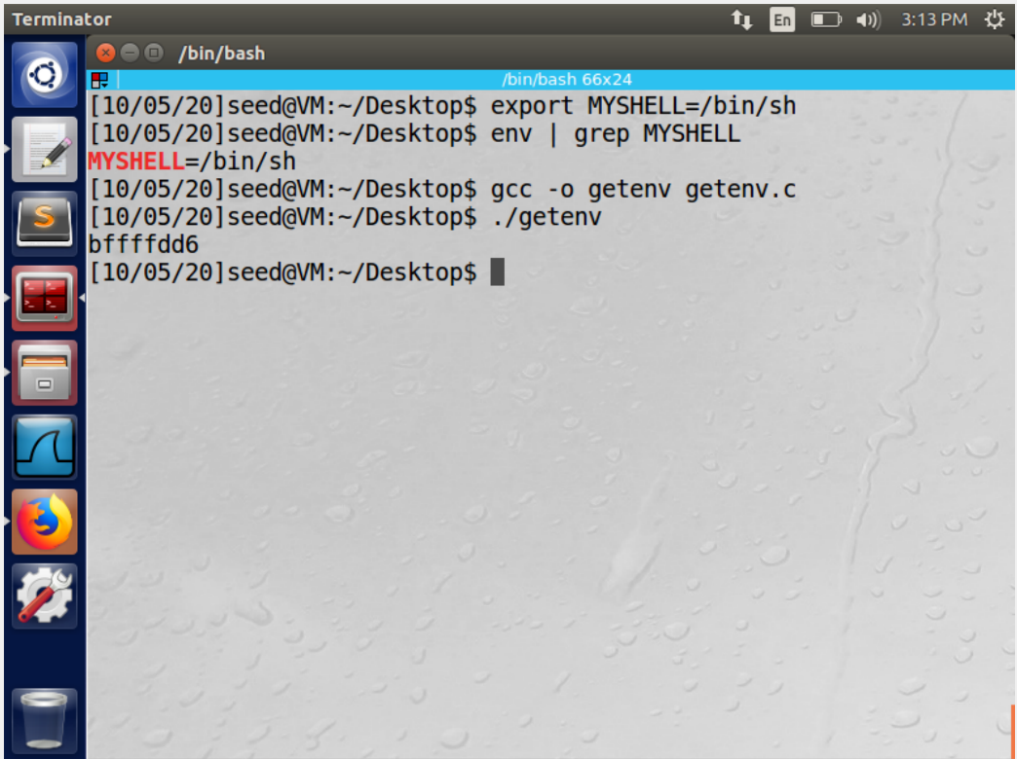

In this task we are required to put the shell string in the memory. The method used to accomplish this task is to use environment variables. We declare a new shell variable “MYSHELL” and make it contain the string "/bin/sh ''. Shell spawns a child process to execute the program . This is further verified using the grep command. The address of this variable can be found by executing the program.

**Task 3: Exploiting the buffer-overflow vulnerability**

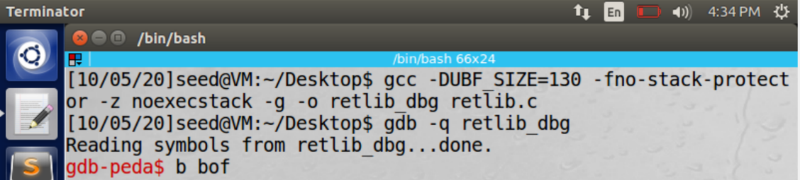

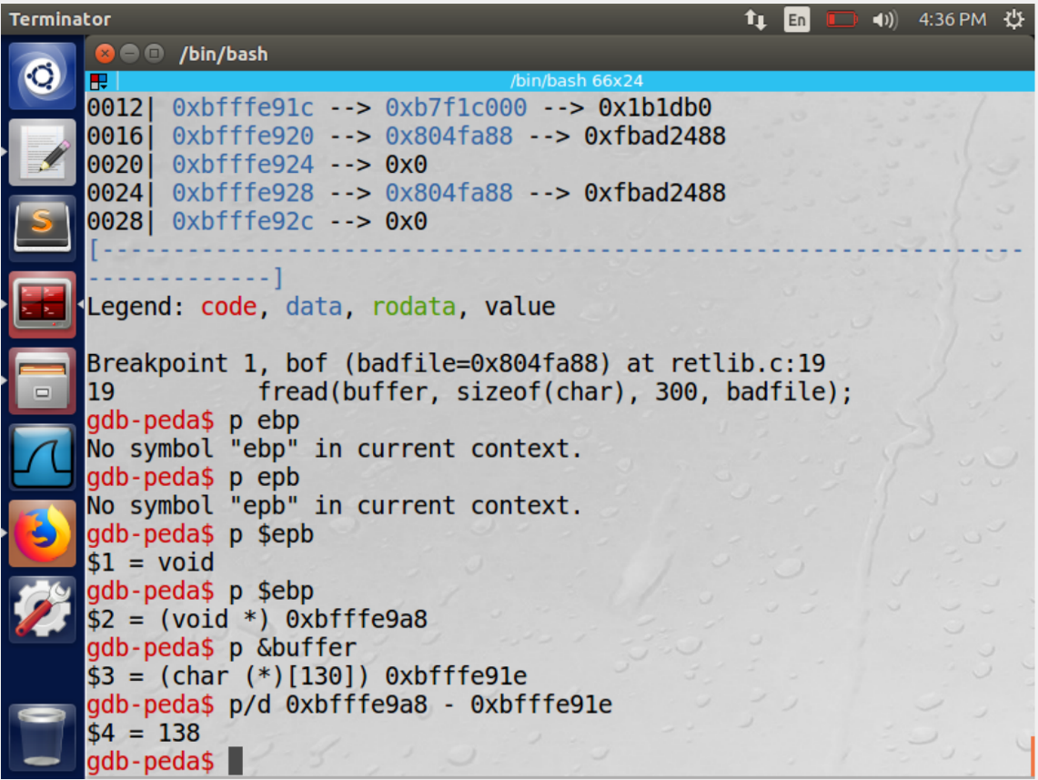

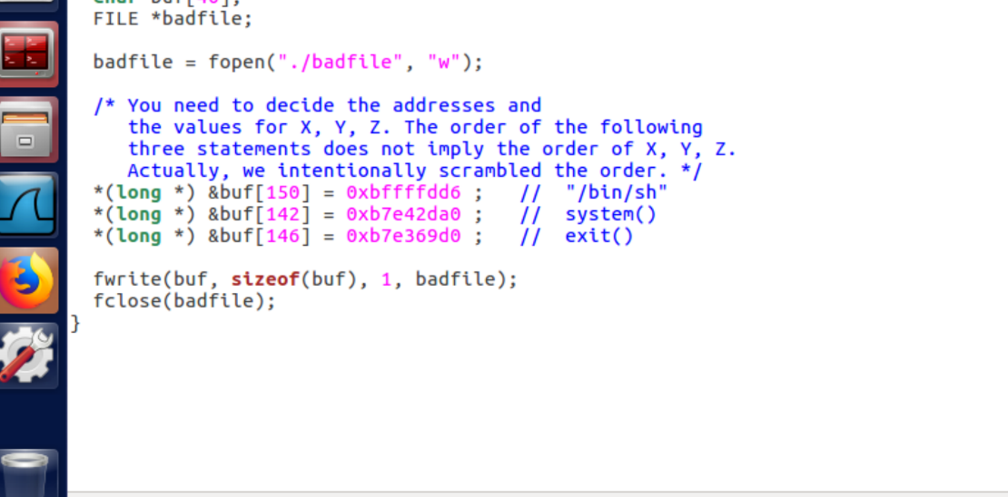

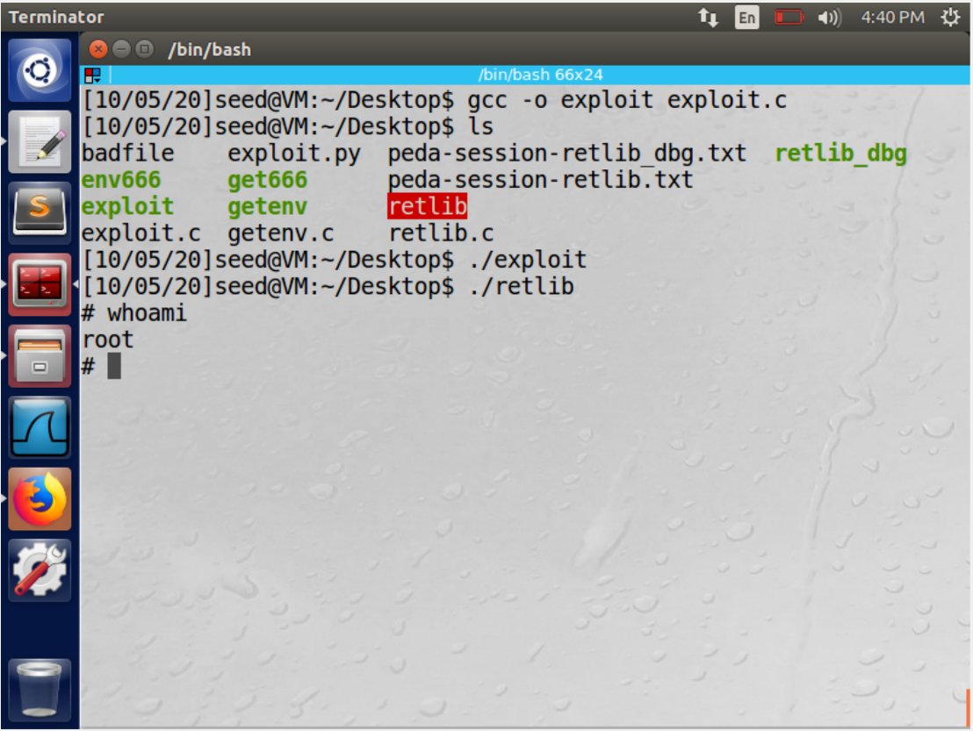

First we turn off address randomization.

we make the /bin/sh symbolic link point to the /bin/dash.

The addresses of the libc functions and the shell addresses are taken, from the tasks 1 and 2 and put into the exploit program provided

We calculate and input the values of X,Y and Z. From the debug option we fine the address of EPB and Buffer. The difference between $ebp and buffer gives us the offset. We are now sure that the system value would be offset+4 and the value for exit would be offset+8 and the value for the shell address would be offset+12 respectively.

we then compile and run exploit.c then run retlib. Thus we get access to the root shell.

**Variation 1**

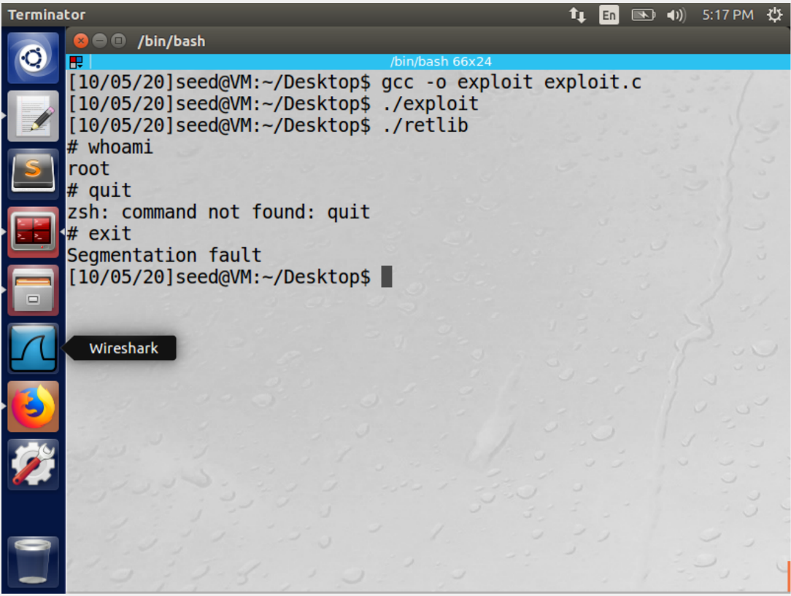

Address for exit is not necessary. The attack still works and we still get access to the root shell. But a point to note here is when we try to exit the root shell we get an error and the exit is not smooth. This is because we have omitted the address of the exit.

**Variation 2**

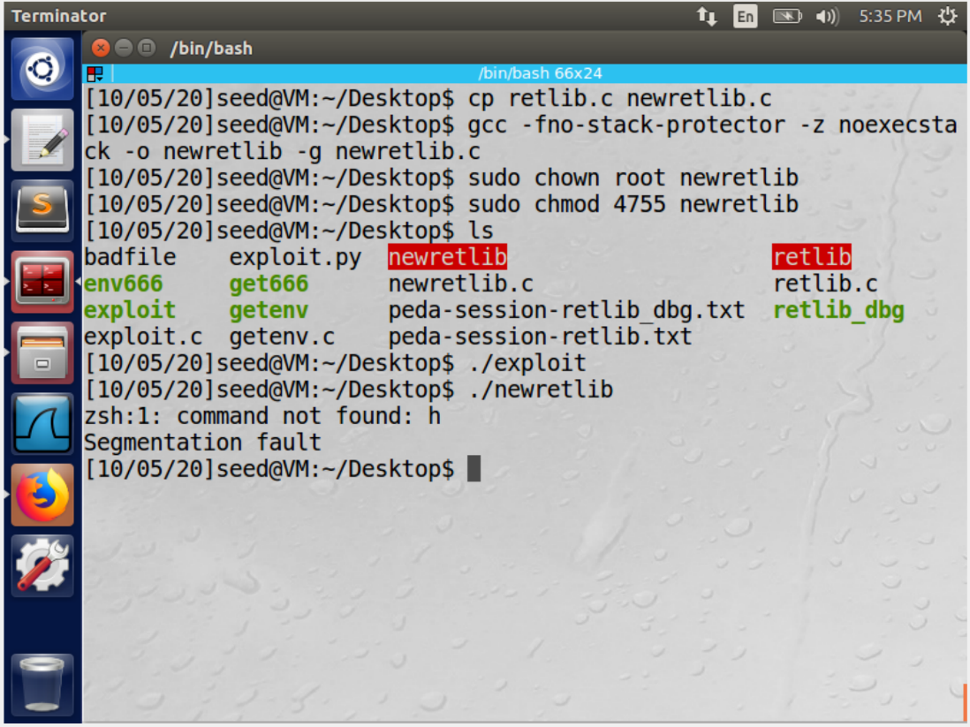

In this task we change the name of the file to newretlib. Then make it a setuid program. We then perform the attack in the similar fashion but now with the newretlib file instead of retlib. We observe that the attack is not successful.

The reason being, changing the length of vulnerable program name, this results in the length of the vulnerable program which does not match with the name length of the program finding the shell address. The change in name length will affect the address of MYSHELL ( /bin/sh address in the exploit program is not the same one and will be a wrong value).

**Task 4: Turning on address randomization**

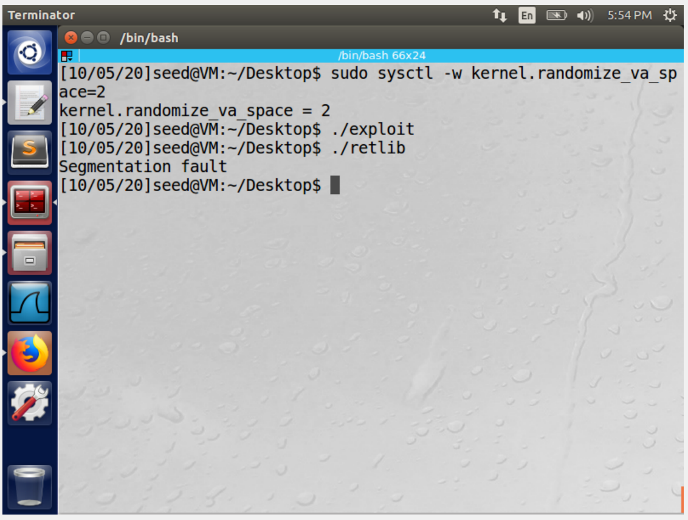

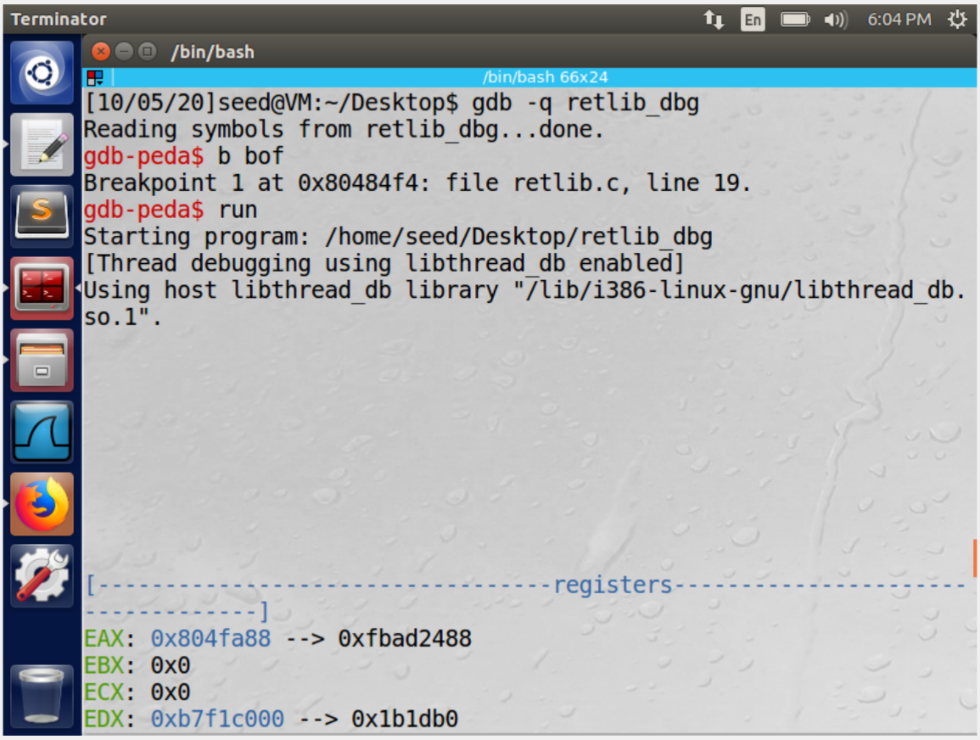

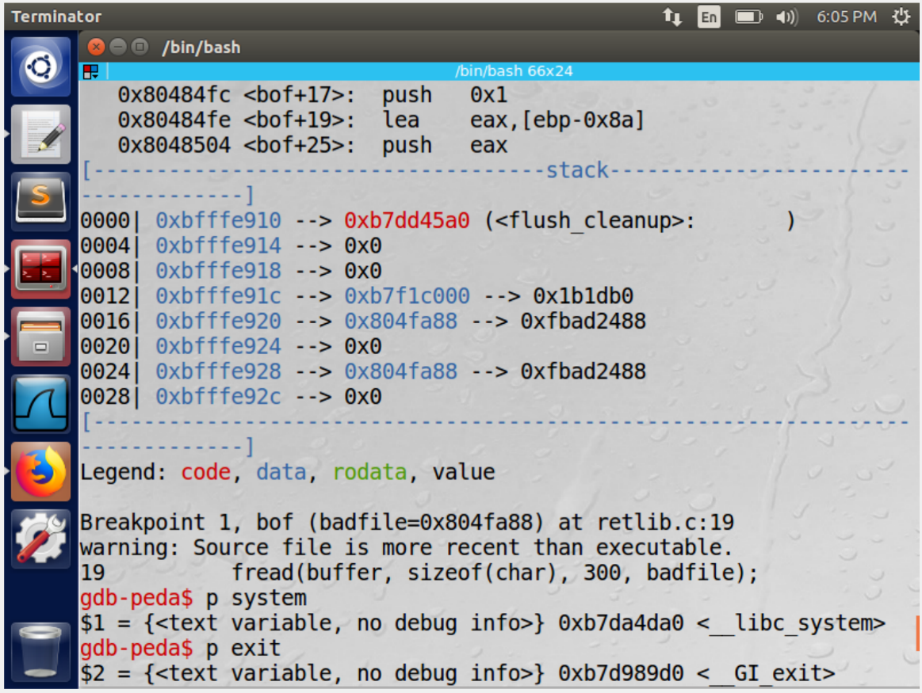

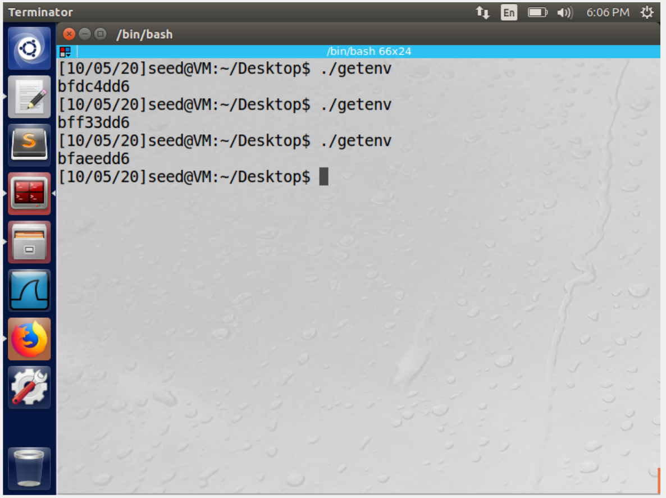

First we turn the address randomization on.

We perform the attack in the similar fashion as previous tasks and we observe that the attack is not successful.

This is because the address of system() and exit() change continuously and randomly.. Therefore predicting the exact address is not possible with the current setting. The probability of predicting the correct address is also low. this mechanism acts as a good protection scheme.

**Task 5: Defeat Shell’s countermeasure**

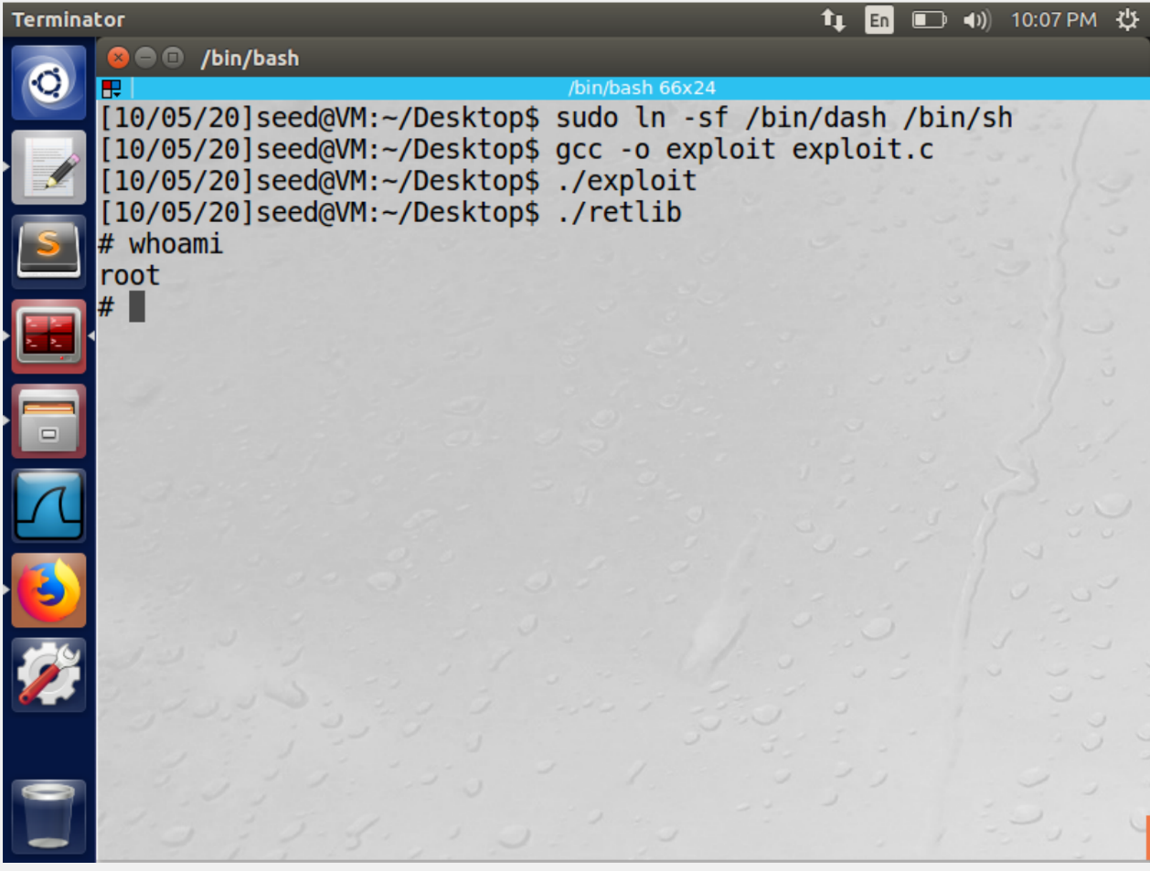

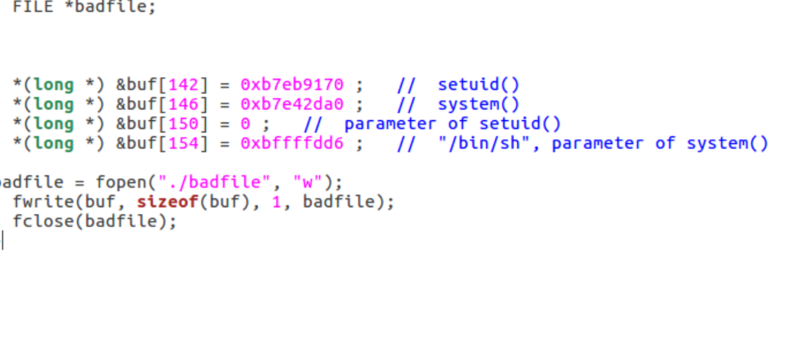

We first perform the prerequisites mentioned in the manual. Since the shells countermeasures are active it will be difficult to attack and get root access with the present exploit program. the approach we have followed to get the root access is to invoke setuid(0) before invoking system(). The setuid(0) call sets both real user ID and effective user ID to 0, turning the process into a non-Set-UID one (it still has the root privilege). Thus modifying and executing the exploit code we get the root access.

**Task 6: Defeat Shell’s countermeasure without putting zeros in input**

The goal of this task is to defeat shells countermeasures without including zeros in the input. The exploit.c is modified as shown and we first fill the buffer with non zero values and then call the SETUID bit. Basically, we first put our payload on the stack (without zeros), and then use the return-to-libc technique to self-modify the data placed on the stack.This helps us to get a root shell.

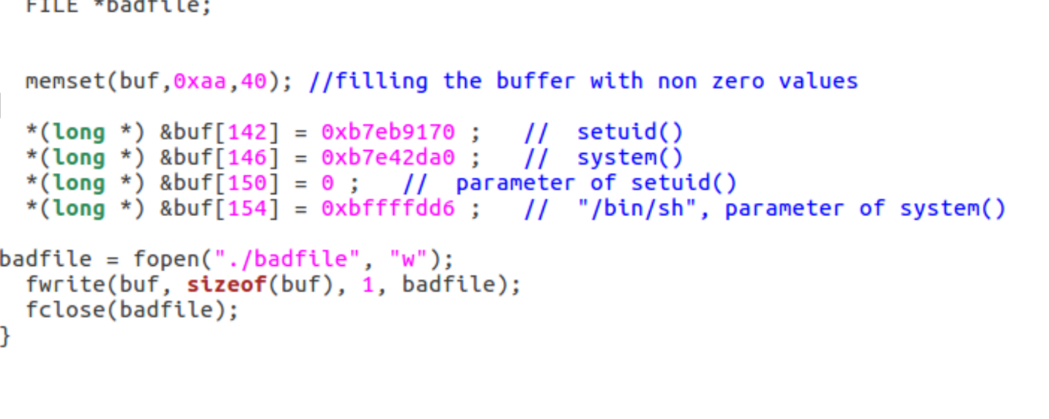

**References**

<http://securesw.dankook.ac.kr/ISS19-2/2019_OS_Se_07_Ret2Libc.pdf>

https://github.com/firmianay/Life-long-Learner/blob/master/SEED-labs/return-to-libc-attack-lab.md